**School Equipment Lending System**

**AUTHOR**: SARUMATHY G.

**ROLL NO**: 2024TM93153

## **1. Introduction**

The School Equipment Lending Portal is a full-stack web application designed to simplify how schools manage the borrowing and lending of educational resources such as lab equipment, projectors, sports gear, and other assets.

The portal provides dedicated interfaces for students, staff, and administrators to perform their respective tasks—students can request or return equipment, staff can approve or monitor requests, and administrators can manage inventory and users efficiently.

The project adopts a **modular, scalable architecture**, built using:

* **Frontend:** React (with Neumorphism UI)
* **Backend:** Node.js + Express.js
* **Database:** MongoDB Atlas (cloud-based)
* **API Testing & Docs:** Swagger and Postman
* **Deployment Support:** Docker (optional)

## **2. System Architecture**

### **Overview**

The architecture follows the **client-server model**, with clear separation between presentation, logic, and data layers.

* **Frontend (React):** Handles all UI/UX rendering, API calls, and state management.
* **Backend (Express + Node.js):** Manages authentication, routing, validation, and data transactions.
* **Database (MongoDB):** Stores users, equipment details, and booking records.
* **Middleware:** Handles authentication (JWT), logging, and error responses.

### **Architecture Diagram**

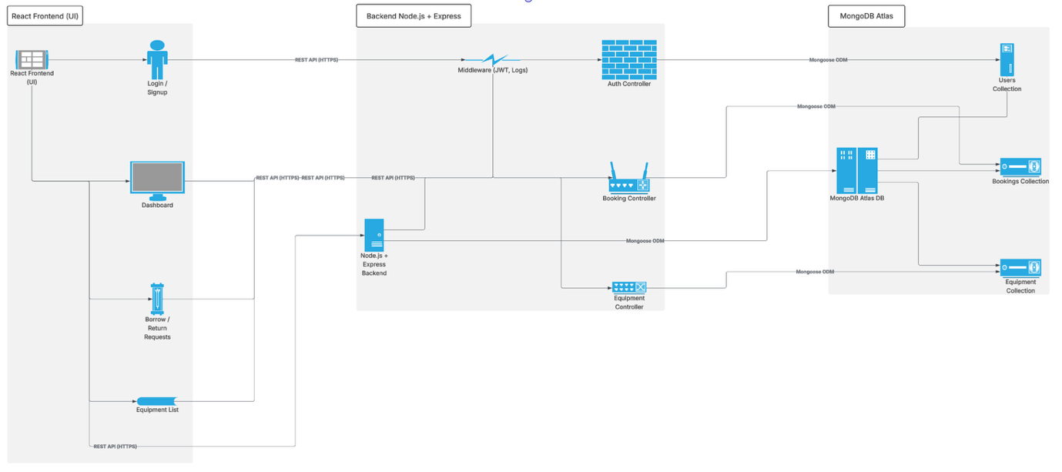

1. The **frontend client (React)** communicates with the backend REST API.
2. The **backend (Express server)** processes incoming HTTP requests and performs validation.
3. The **database layer (MongoDB)** handles CRUD operations for users, items, and bookings.
4. The **middleware layer** (auth, logging, error-handling) ensures security and traceability.
5. **JWT tokens** are used to protect endpoints and manage user sessions.

## **3. Database Schema & Model Design**

### **Entity Models**

* **User** - name, email, password, role (student/staff/admin)
* **Item** - name, category, status, quantity, description, images[]
* **Booking** - userId, itemId, startDate, endDate, status (pending / approved / returned)

### **ER Model Diagram**

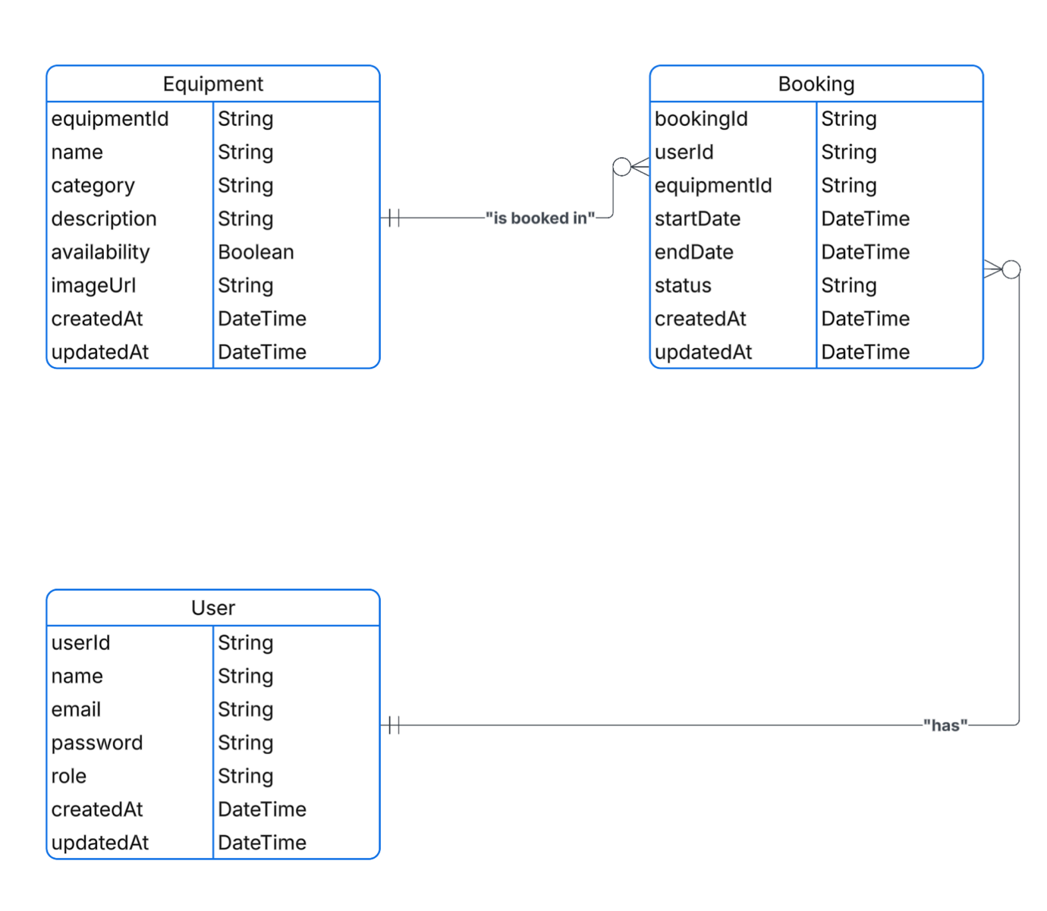

**Relationships:**

* One **User** → Many **Bookings**
* One **Item** → Many **Bookings**
* Admin manages both **Users** and **Items**.

### **Database Rules**

* Unique index on email for user collection.
* Prevent overlapping bookings using date validation logic on the backend.
* Timestamps auto-generated for creation and update tracking.

## **4. Component Hierarchy**

### **Frontend Components**

* **App.js:** Entry point controlling route access and global context.
* **Navbar:** Displays navigation links, profile dropdown, and logout confirmation modal.
* **LandingPage:** Public homepage showing school details, features, and call-to-action buttons.
* **Login & Signup Forms:** Manage authentication with Toastr notifications.
* **Admin Dashboard:** For managing equipment inventory and user activities.
* **Booking Section:** Lists borrowed items and booking history for users.
* **ConfirmModal / Dialog:** Used for actions like delete or logout confirmation.

### **Backend Components**

* **server.js:** Main entry point, connects to MongoDB, configures routes and middlewares.
* **Routes:**
  + /auth – User registration, login, token verification.
  + /items – CRUD for equipment (admin-only).
  + /bookings – Handle borrowing, returning, and conflict checks.
* **Middleware:**
  + authMiddleware – JWT authentication.
  + errorHandler – Unified API error responses.
* **Models:** Mongoose schema definitions for User, Item, and Booking.

## **5. UI/UX Conceptual Guide**

### **Design Philosophy**

The interface is developed using the **Neumorphism design style**, which blends modern flat design with subtle depth effects. It emphasizes a soft, tactile look to make interaction feel natural and calm—ideal for educational environments.

### **UI Flow**

1. **Landing Page:**
   * Describes the purpose of the portal and has buttons for Login or Sign up.
   * Includes attractive images of school equipment and modern classroom activities.
2. **Authentication:**
   * Toastr notifications appear on successful signup/login.
   * Errors like “invalid credentials” or “existing email” are displayed clearly.
3. **Dashboard (After Login):**
   * Personalized view depending on role:
   * **Student:** Browse and borrow items
   * **Staff:** Approve or return equipment
   * **Admin:** Add/edit/delete items, manage users
4. **Modals and Interactions:**
   * Logout confirmation modal to prevent accidental sign-outs
   * Delete confirmation modal before removing items
   * Toastr success/failure alerts for all critical actions
5. **Responsiveness:**
   * Fully responsive layout optimized for desktops, tablets, and mobile devices.

### **UI ScreenSHOTS**

1. Landing Screen

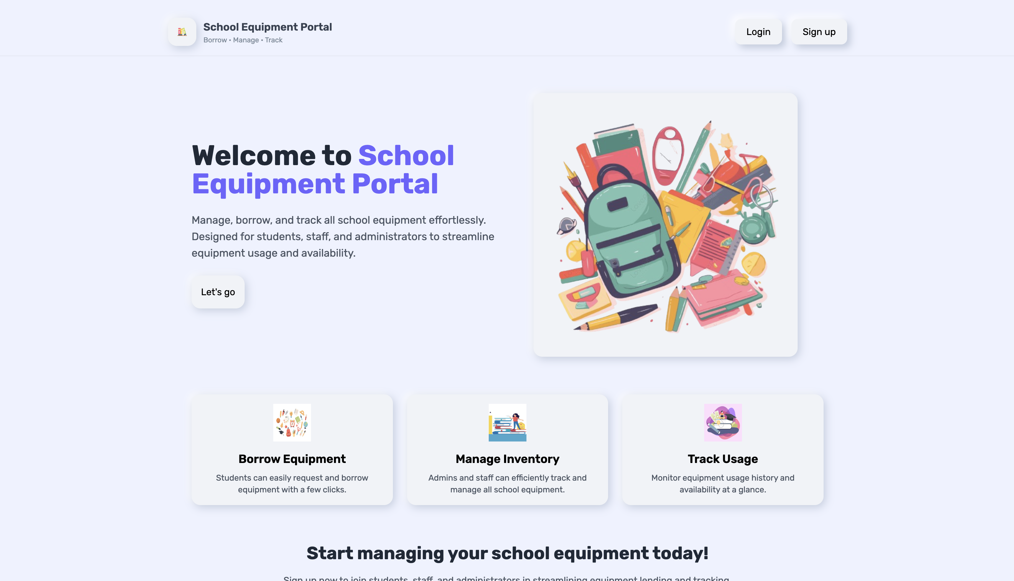

1. Sign-up Screen

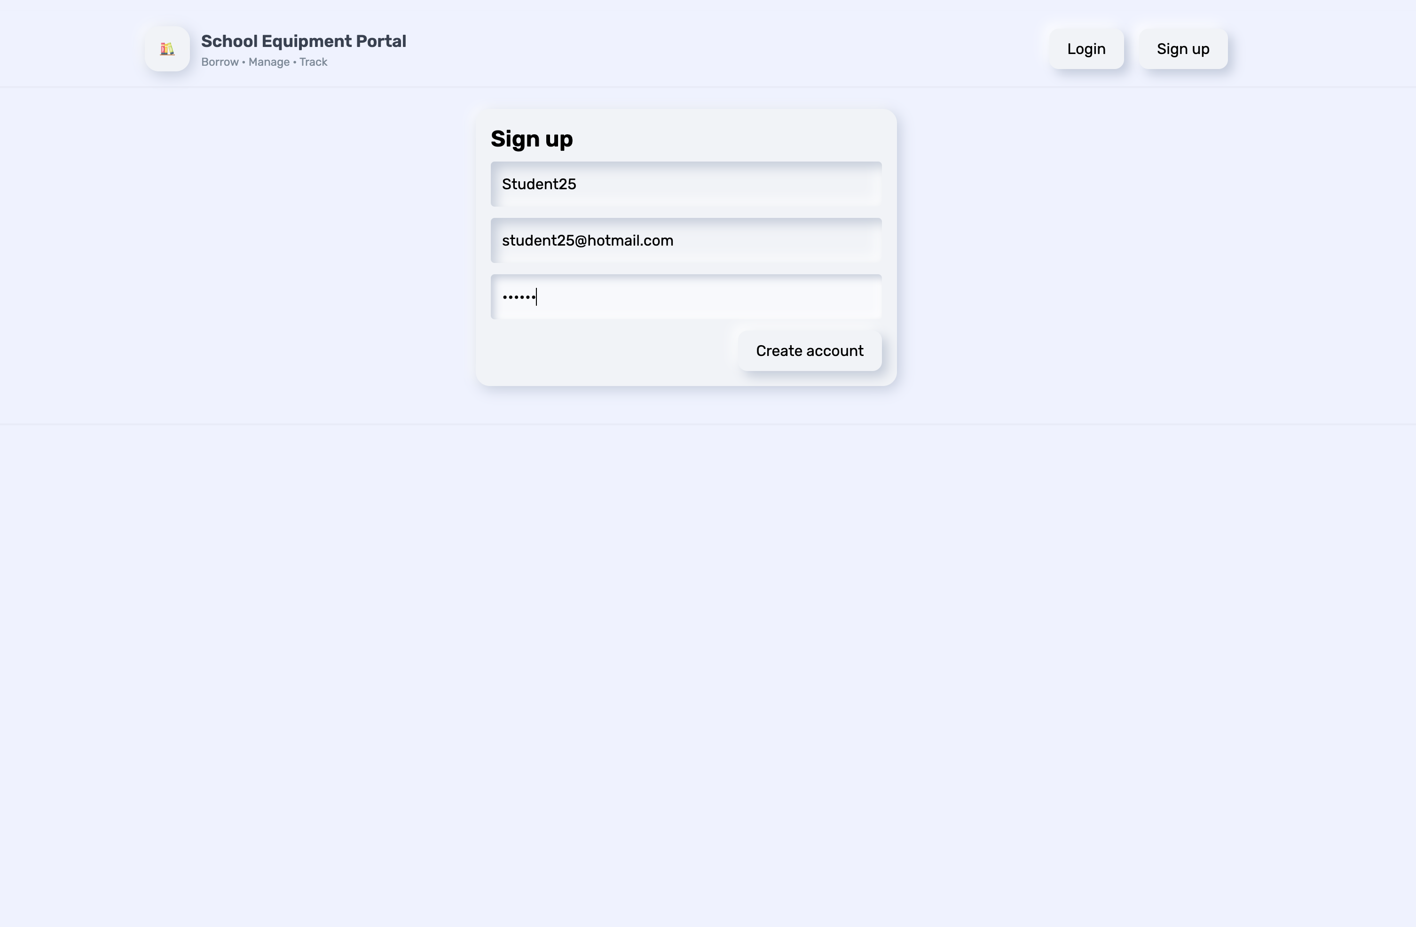

1. List of Items

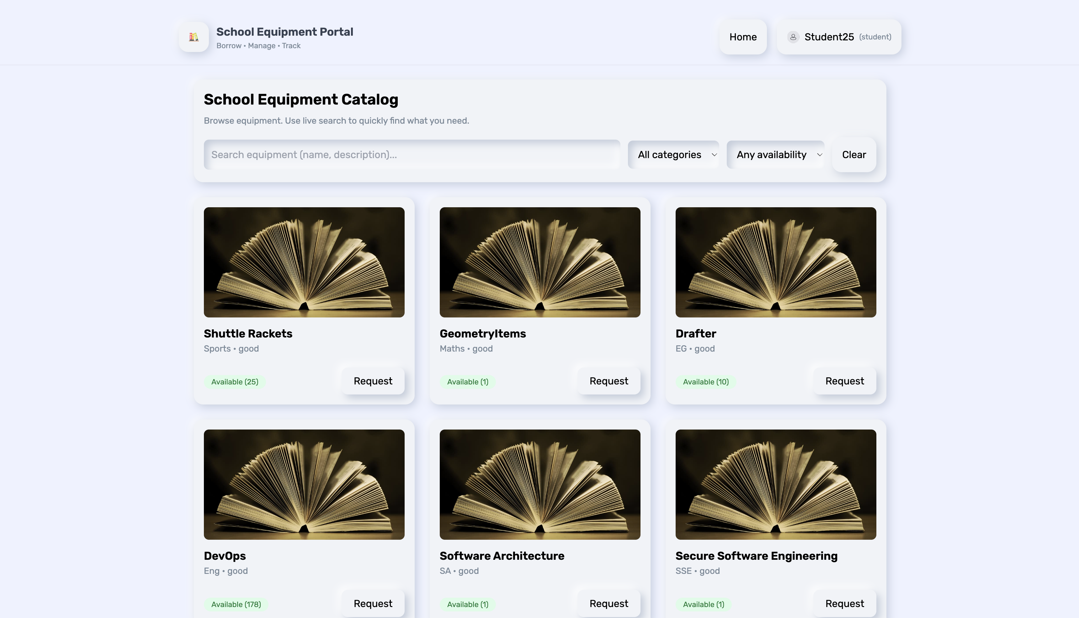

1. Search & Filter

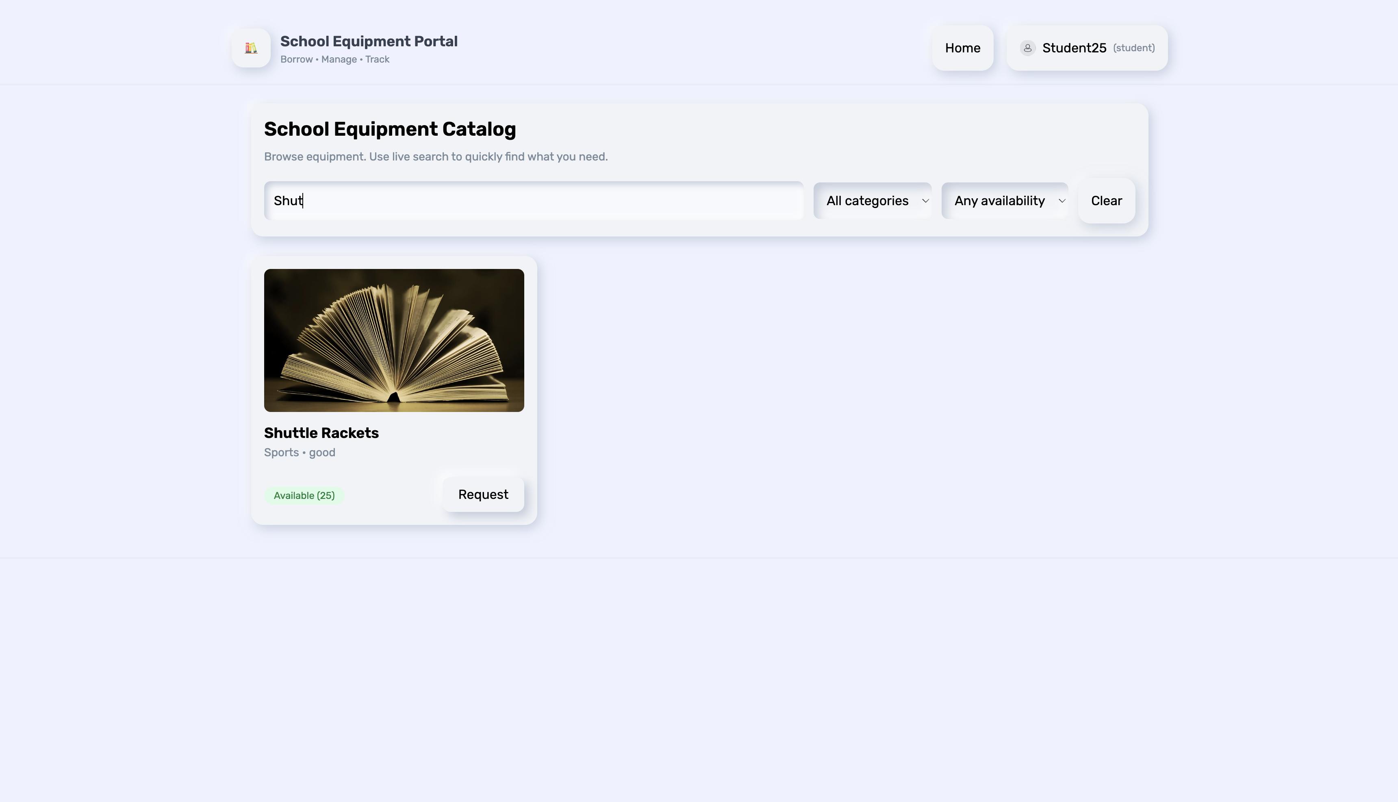

1. Request of Item

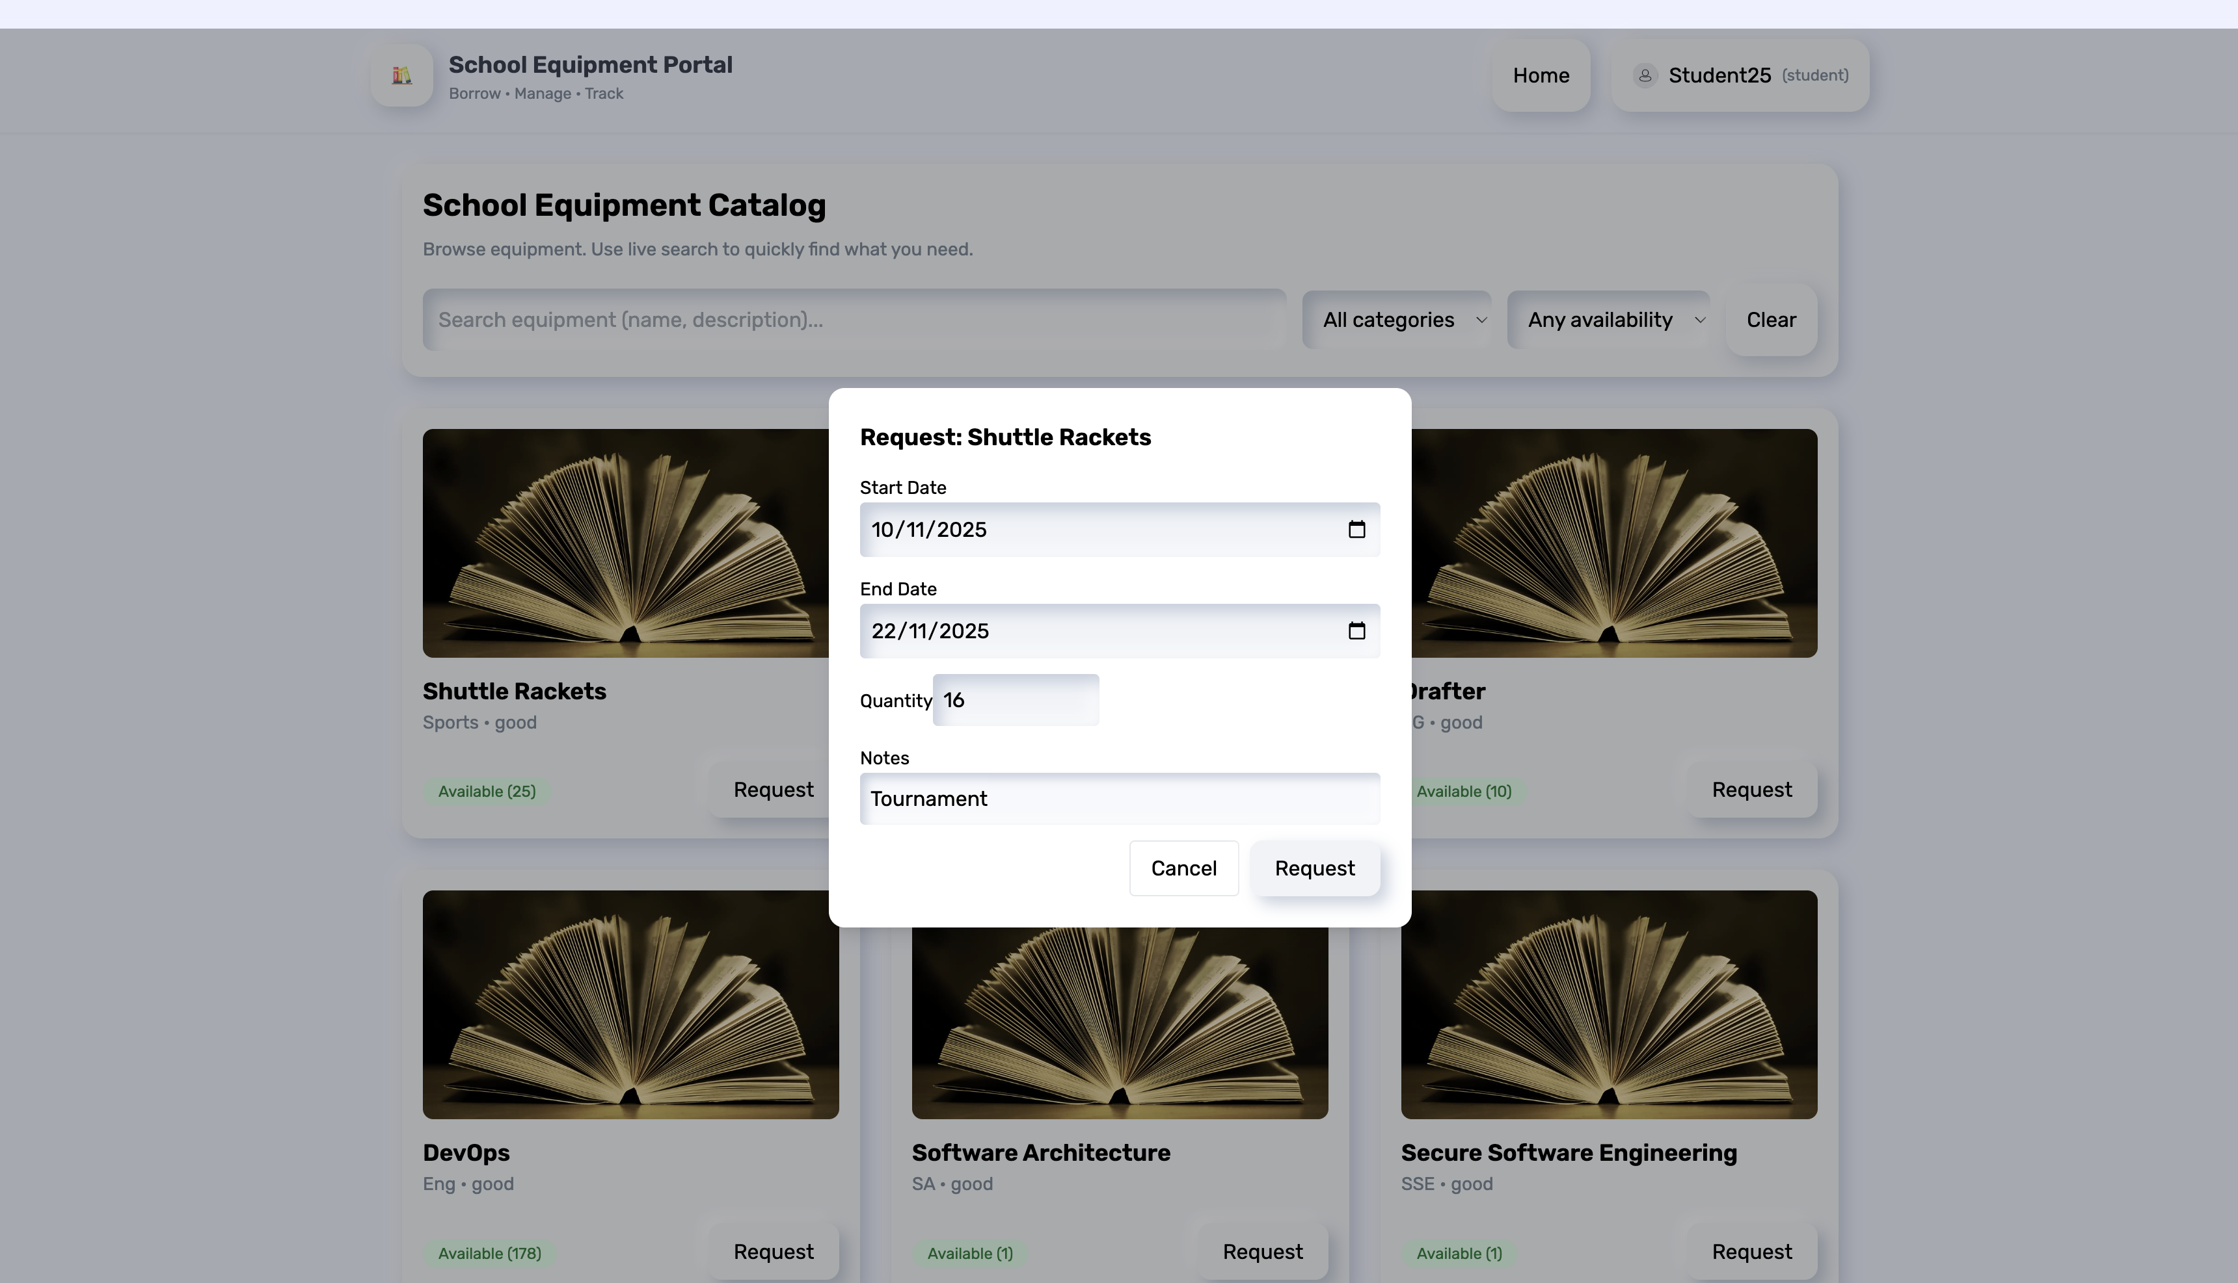

1. Toastr of requesting an item

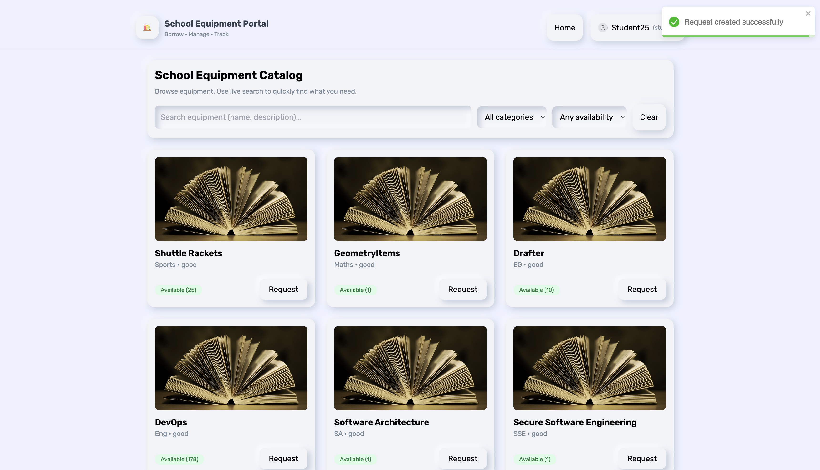

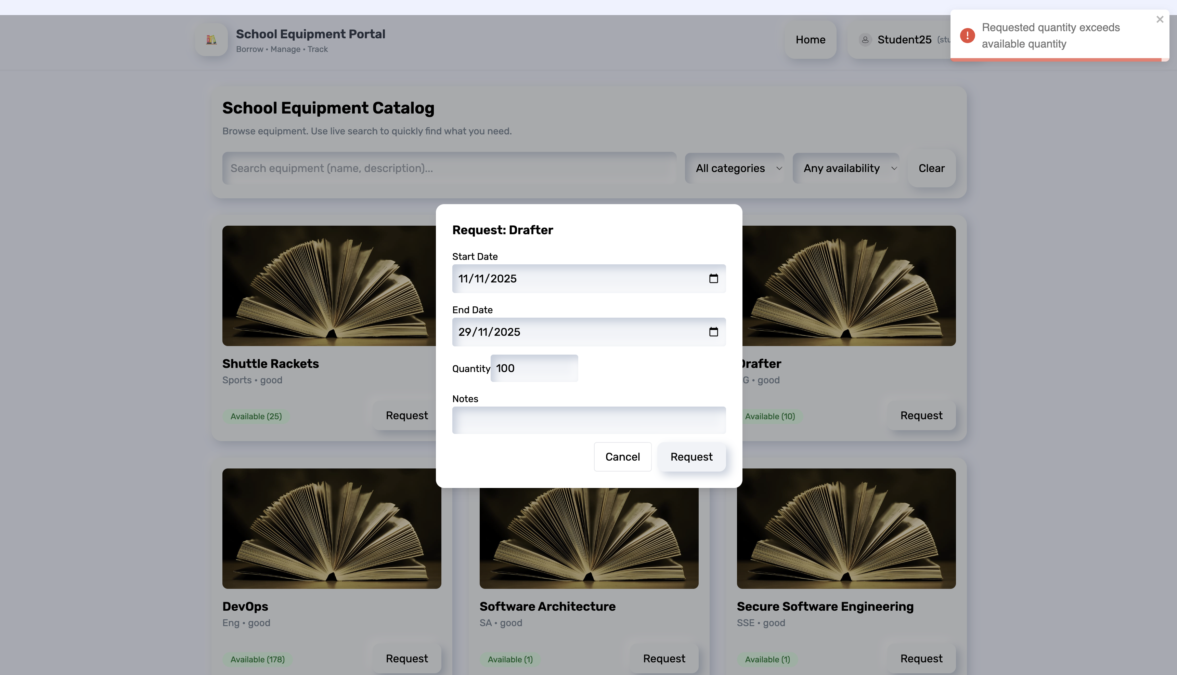

1. Login Screen (Admin)

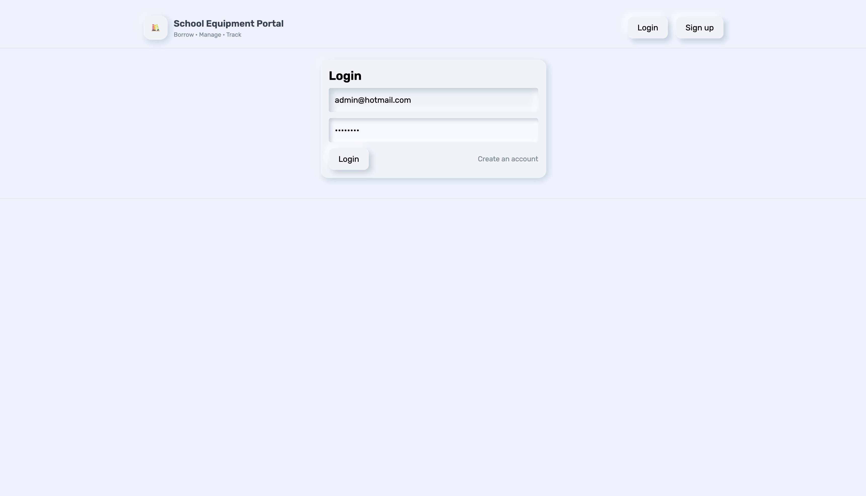

1. Manage Screen (Admin)

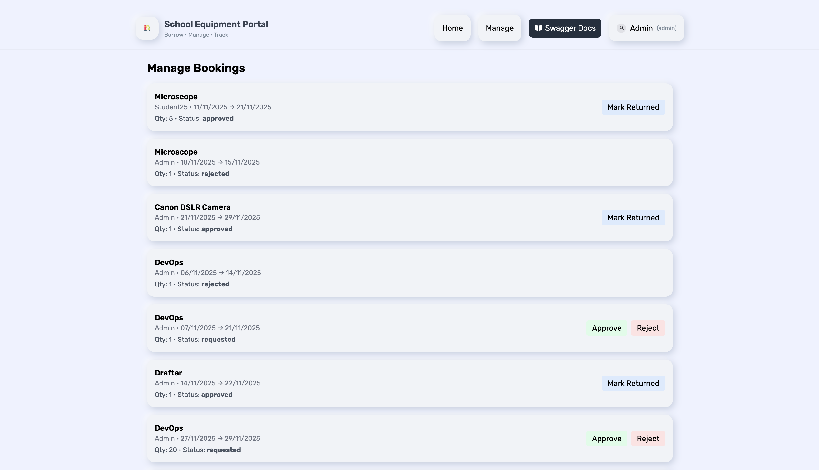

1. Adding of Items (Admin)

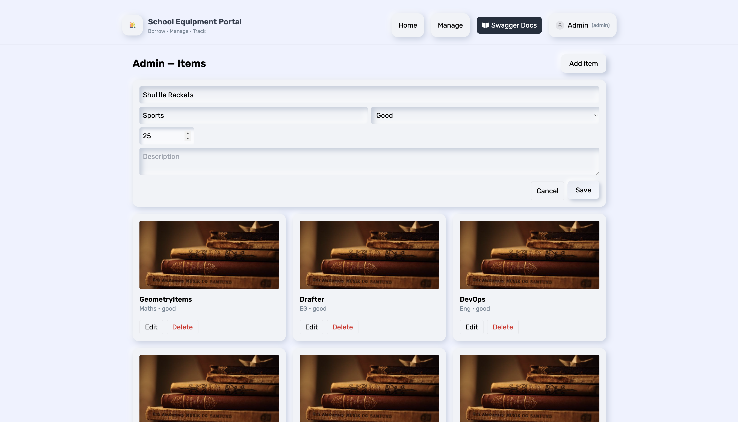

1. Toastr Notification

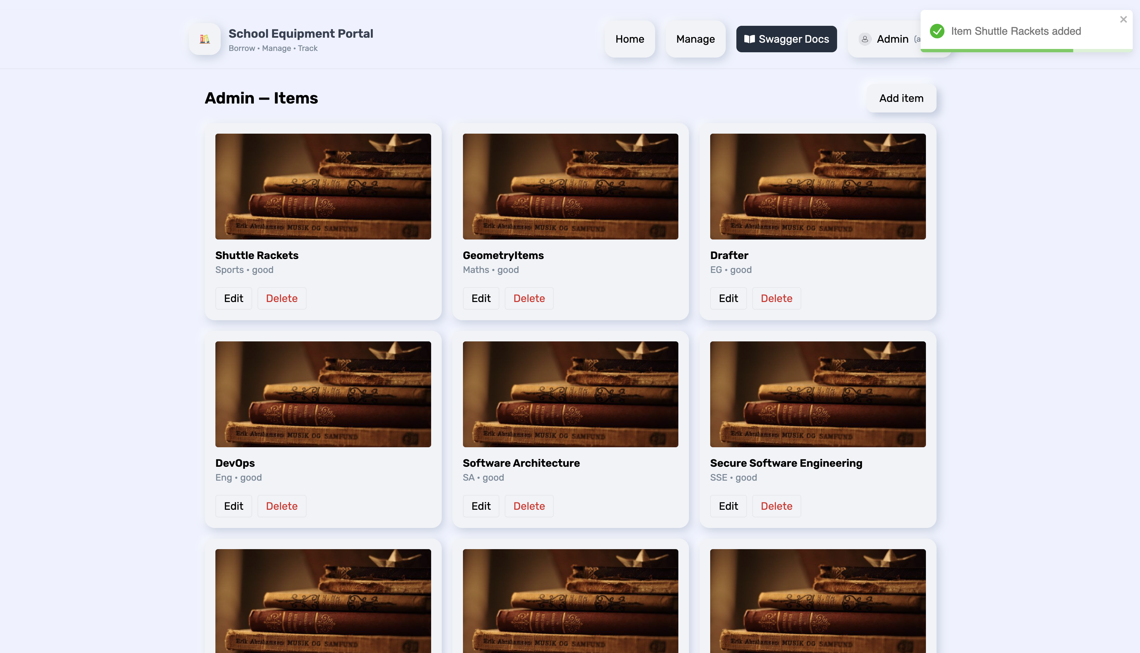

1. Confirmation dialog for deletion of an item

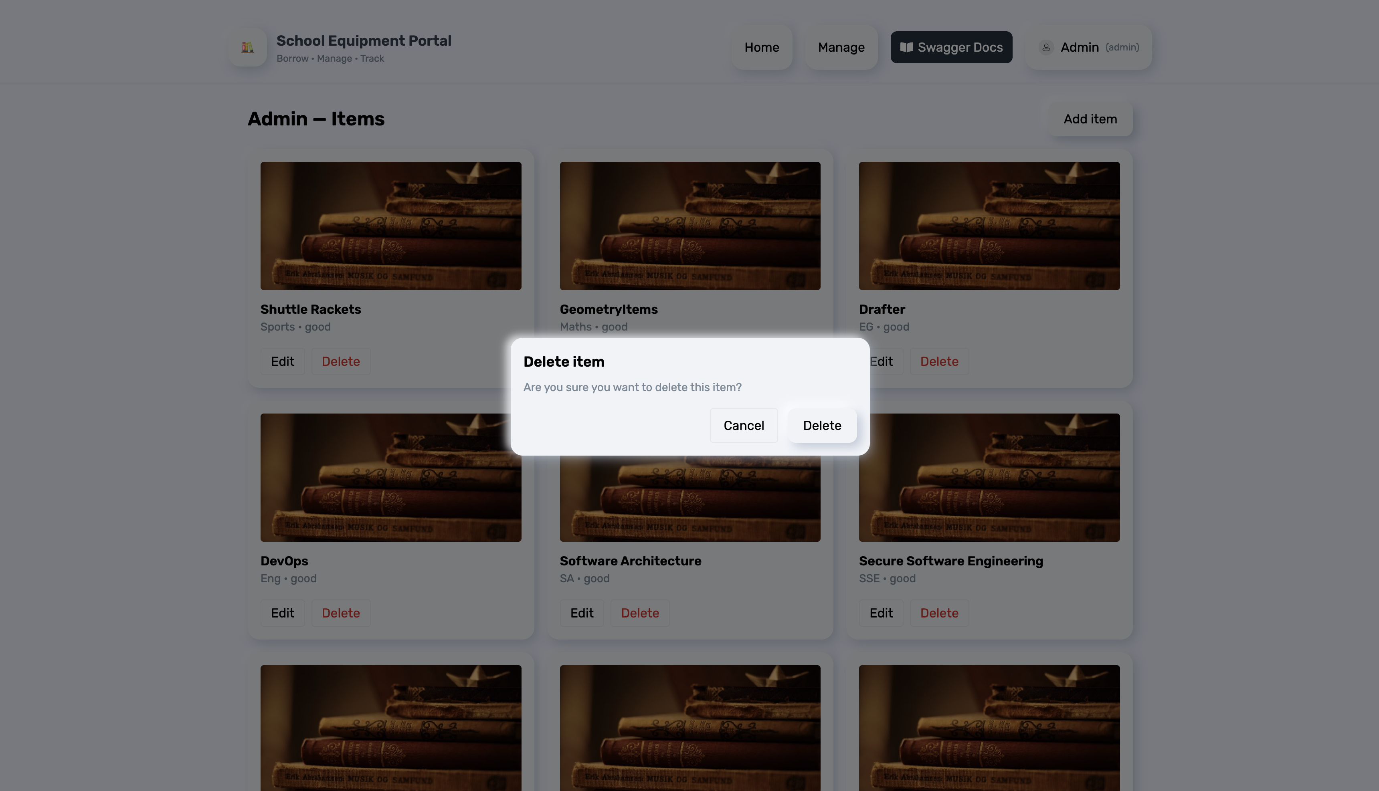

1. Swagger Docs

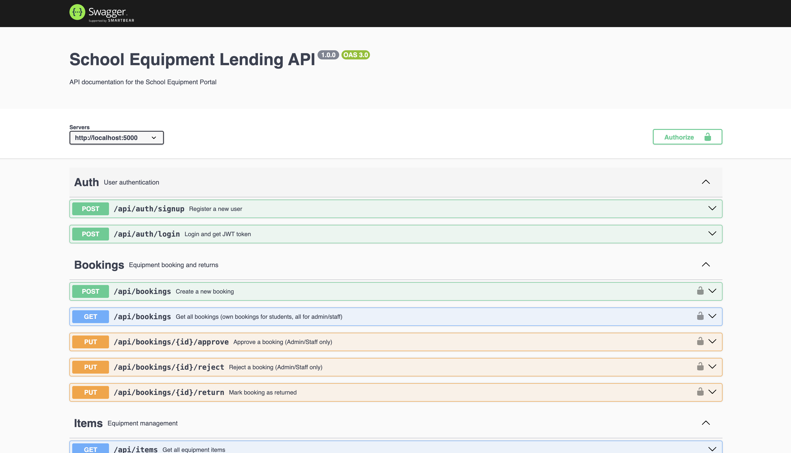

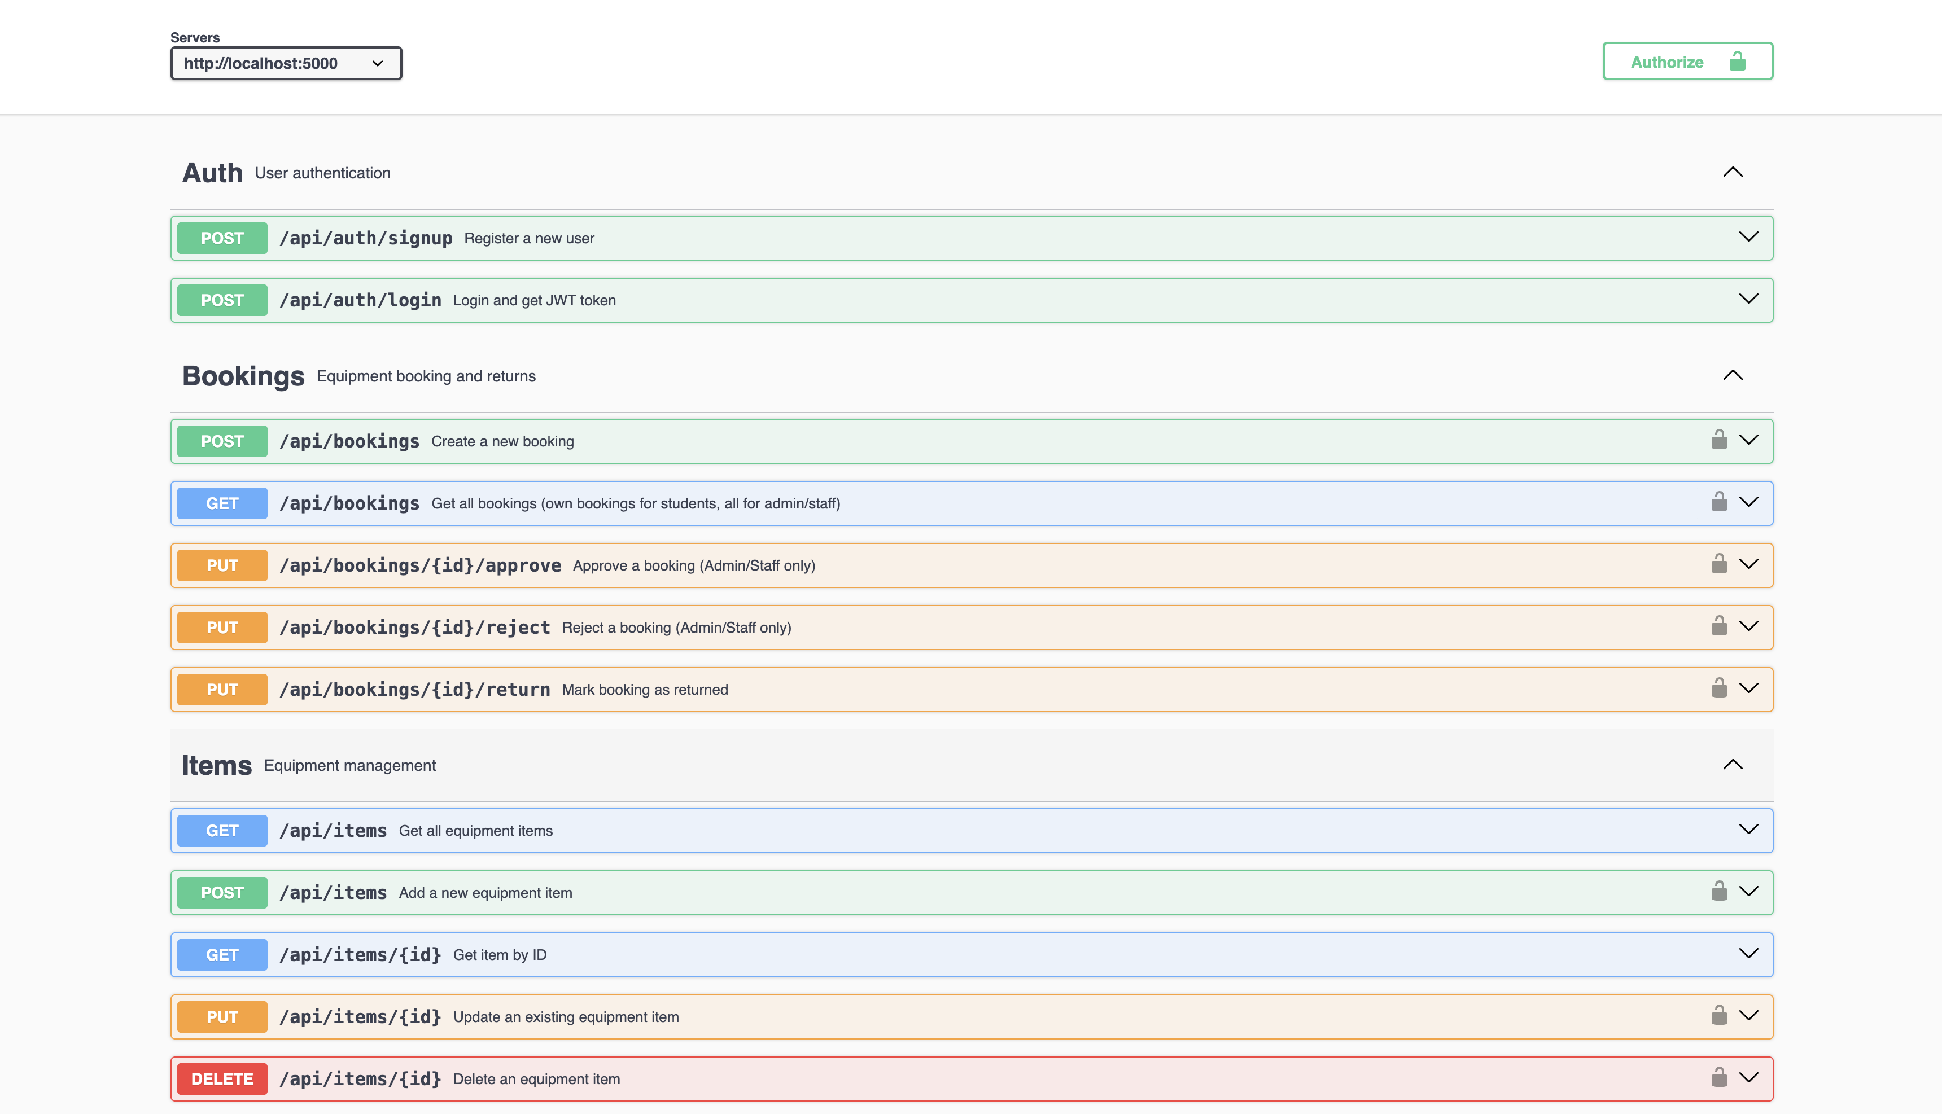

1. Logout Confirmation

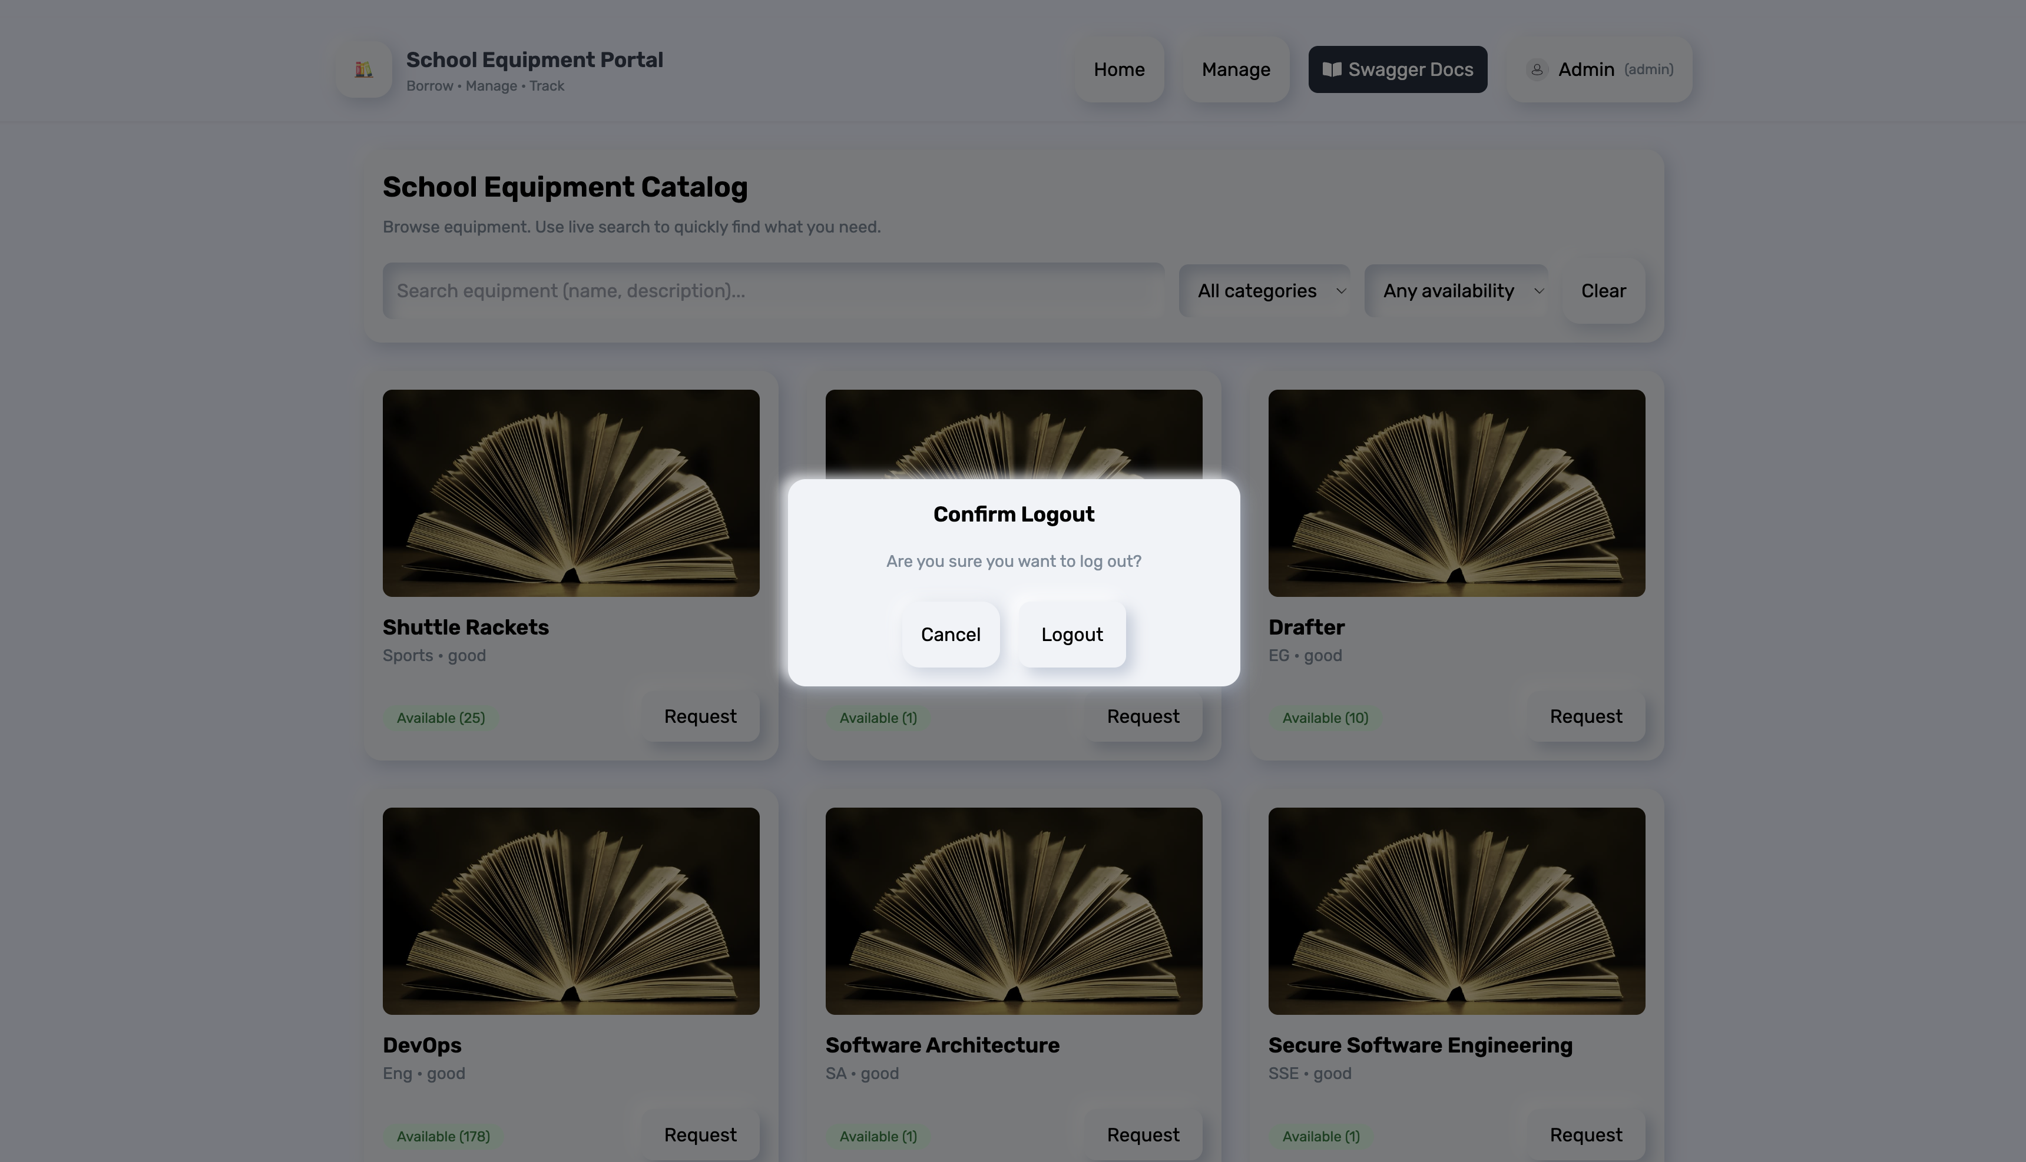

## **6. Assumptions**

* Users are registered by self-signup or by the admin.
* Each item has a unique identifier and optional image file.
* Booking requests are validated for date conflicts (no overlapping).
* The system supports multiple concurrent sessions with JWT-based authentication.
* Admin approval is mandatory for new item creation or modifications.

## **7. Conclusion**

The School Equipment Lending Portal demonstrates a well-balanced integration of user experience, security, and functional scalability.  
By combining a **React frontend** and **Node.js backend** with a **MongoDB Atlas** cloud database, it ensures both flexibility and robustness.

The **Neumorphism-based interface** adds visual appeal and promotes intuitive navigation.

This solution provides a real-world, deployable system that can be expanded for institution-level asset management, helping schools transition from manual tracking to an intelligent, digital ecosystem.